Research Design Documentation

Project Title: Grounding Volatile Time-Series Forecasting via Causal Knowledge Graph Constraints (The "Symbolic Seam" Architecture)

Executive Summary & Abstract:
Standard deep learning architectures for time-series forecasting (e.g., LSTMs, Temporal Fusion Transformers) operate entirely on statistical momentum and historical patterns. While highly effective during stable economic or operational cycles, these "System 1" models fail catastrophically during Black Swan events, sudden regulatory shifts, or structural supply chain disruptions. Because they lack real-world logic, they generate predictions that violate fundamental physical, legal, or causal realities.
This research project introduces The Symbolic Seam, a novel Neuro-Symbolic framework that bridges continuous statistical forecasting with discrete causal logic. By intercepting raw neural forecasts (System 1) and evaluating them against a dynamic, rule-based Knowledge Graph (System 2), the architecture mathematically ensures that all outputs conform to hard operational boundaries and causal constraints in real-time.

Problem Statement & Research Motivation

The Core Flaw of Pure Deep Learning (System 1)
Deep sequence models assume the future is a function of statistical distributions found in the past. If a country suddenly changes its import/export tariffs, or a major shipping canal is blocked, a traditional LSTM has no mechanism to ingest this textual or structural rule change. It will continue predicting trends based on pre-disruption momentum, leading to highly inaccurate and physically impossible forecasts.

The Opportunity of Knowledge Graphs (System 2)
Knowledge Graphs (KGs) store information as deterministic entities and relationships (e.g., [Port A] --Connected_To--> [Route B]). They excel at holding absolute truths, legal constraints, and causal rules. However, they cannot look at messy, fluctuating market data and predict tomorrow's exact price or shipping duration.

The Research Gap
Current research either focuses on using KGs to create features for deep learning models, or using deep learning to predict missing links in KGs. Almost no literature focuses on post-hoc real-time verification, where a symbolic layer acts as a strict compliance referee over a continuous numerical neural forecast.

System Architecture Blueprint
The proposed framework splits the forecasting pipeline into three distinct operational zones:
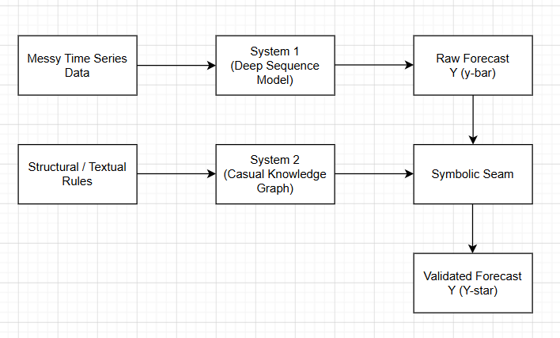

A. System 1: The Neural Perception Layer
- Role: Handles multi-variable sequence processing and extracts temporal dependencies.
- Candidate Architectures: Temporal Fusion Transformers (TFT), PatchTST, or Multi-Task LSTMs.
- Input: Structured, high-frequency historical data (e.g., daily freight rates, asset prices, volume metrics).
- Output: A raw, unbounded statistical forecast vector $\hat{y}_{t+1:t+k}$.

B. System 2: The Symbolic Logic Layer
- Role: Maintains the ground-truth operating environment, structural dependencies, and explicit boundaries.
- Candidate Architectures: Neo4j, Resource Description Framework (RDF) triples, or Ontologies utilizing Description Logics.
- Input: Multi-modal structural rules (e.g., compliance text, supply chain routing capacities, trade tariffs, contractual maximums).
- Output: A set of dynamic mathematical constraints expressed as matrix boundaries.

C. The Core Innovation: The Symbolic Seam
The "Symbolic Seam" is the mathematical compiler where the neural vector and symbolic logic collide. Instead of letting System 1 output its raw guess, the Seam treats the neural prediction as an initial proposal and maps it into a mathematically constrained optimization space governed by System 2.

4. Methodology & Mathematical Framework
To connect continuous neural outputs with discrete symbolic rules, the Symbolic Seam formulates the final prediction as a Constrained Projection Problem.
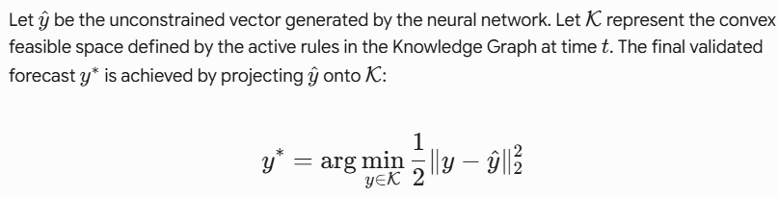
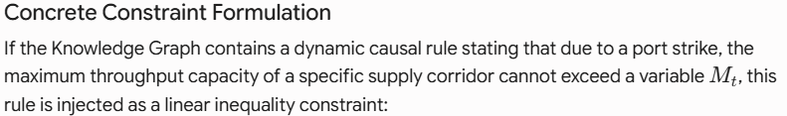
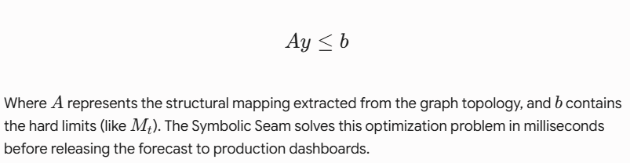

5. Data Engineering & Graph Construction
Data Type | Source Pipeline | Role in Architecture
Numerical Sequences | Market feeds, historical shipping logs, inventory levels | Trains the System 1 Neural Model to capture baseline market momentum.
Unstructured Text | Regulatory filings, maritime news feeds, legal contracts | Parsed using entity extraction to dynamically update nodes and edges in the KG.
Deterministic Topology | Geographic routes, pipeline networks, corporate ownership hierarchies | Forms the static backbone of the System 2 Knowledge Graph.

Knowledge Graph Schema Design
Nodes will represent physical assets (Ports, Warehouses), economic entities (Commodities, Currencies), or regulatory states. Edges will represent directed causal impacts (e.g., [Tariff_Increase] --Reduces_Capacity_By_20%--> [Trade_Route_X]).

Evaluation Metrics & Validation Strategy
To prove this research solves a real-world problem, the architecture must be evaluated using two distinct classes of metrics:

1. Statistical Accuracy Metrics
- Root Mean Squared Error (RMSE) & Mean Absolute Percentage Error (MAPE): Evaluated specifically during standard operational windows vs. high-volatility/Black Swan windows.
- Hypothesis: Pure deep learning will win during normal windows, but the Neuro-Symbolic model will dramatically outperform it during disruptive events.
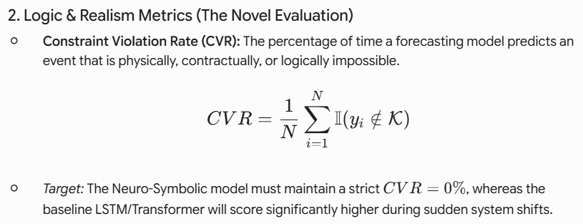

7. Anticipated Implementation Challenges
- Differentiability vs. Post-Hoc Optimization: Solving a quadratic programming problem at the end of a neural network adds computational overhead. Research must find a balance between calculating this inside the loss function (end-to-end training) or as a lightning-fast inference-time filter.
- Graph Latency: If the Knowledge Graph is massive, querying it in real-time to extract constraints for every forward pass of the time-series model can cause latency bottlenecks. Optimizations using sub-graph extraction or localized tensor representations of the graph will be required.
- Contradictory Rules: In real-world scenarios, multiple text sources might feed conflicting information to the Knowledge Graph. The symbolic layer must include a logic-arbitration mechanism (e.g., confidence scoring on graph edges) to resolve conflicting constraints before binding the neural layer.

